### **Quiz 1: Easy (Dividing Decimals)**

1. What is 6.4 ÷ 2?  
   * A) 2.2
   * B) 3.2
   * C) 4.2
   * D) 5.2
2. If you divide 9.0 by 3, what is the result?  
   * A) 2.0
   * B) 3.0
   * C) 4.0
   * D) 5.0
3. What is 5.5 ÷ 1.1?  
   * A) 4.0
   * B) 5.0
   * C) 5.5
   * D) 6.0
4. How much is 8.8 ÷ 4?  
   * A) 1.8
   * B) 2.0
   * C) 2.2
   * D) 2.4
5. What is the quotient of 7.2 and 2.4?  
   * A) 2.0
   * B) 2.5
   * C) 3.0
   * D) 3.5

**Quiz 1:**

1. B
2. B
3. B
4. C
5. C

### **Quiz 2: Hard (Dividing Decimals)**

1. What is 15.75 ÷ 0.25?  
   * A) 60
   * B) 62
   * C) 64
   * D) 66
2. If a car travels 123.45 miles in 2.5 hours, what is its average speed?  
   * A) 48.5 mph
   * B) 49.5 mph
   * C) 50.5 mph
   * D) 51.5 mph
3. Calculate 9.6 ÷ 0.8.  
   * A) 11
   * B) 12
   * C) 13
   * D) 14
4. What is the result of 45.6 ÷ 1.2?  
   * A) 36
   * B) 37
   * C) 38
   * D) 39
5. How much is 100.0 ÷ 4.0?  
   * A) 24
   * B) 25
   * C) 26
   * D) 27

**Quiz 2:**

1. A
2. A
3. B
4. A
5. B

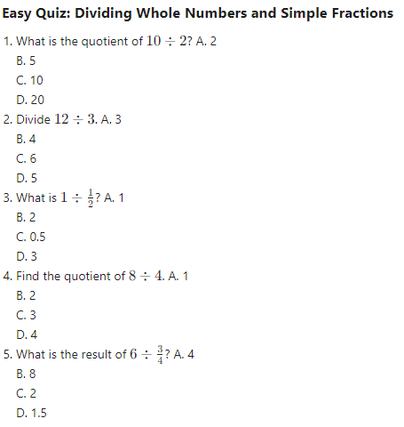

**Easy Quiz:**

1. B
2. B
3. B
4. B
5. B

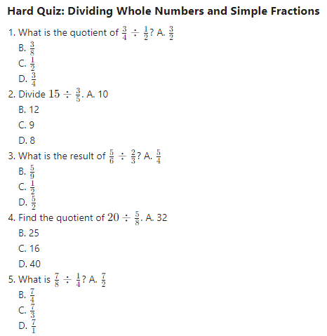

**Hard Quiz:**

1. A
2. A
3. A
4. A
5. A